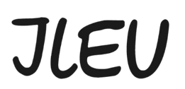

Photo action “Stand up for Europe and Democracy”
The legal guardian hereby consents to the minor’s participation in the activity.
Please fill out, sign and send the document to democracy@ileu.net

I/We, ______________________________, ____________________________________,
(First and last name of legal guardian) as legal guardian(s) of __________________________, (first name, last name of participating minor) born on ______________________ (date of birth)
Street: ________________________________________________________
Postcode, residence: _____________________________________________
Telephone: _______________________________________________________
Email: ________________________________________________________
agree that our daughter/son may participate in the photo action “Stand up for Europe and Democracy” and agree to the conditions of participation, in particular to the transfer of rights to the photographs contained therein.

We have taken note of and approved ILEU’s privacy policy.
___________________________,______________________
Place, date
__________________________________________________
Signature of the legal guardian(s)

